1. 拉取镜像

docker pull registry.cn-hangzhou.aliyuncs.com/helowin/oracle_11g

1. 创建容器

docker run -d -p 1521:1521 --name oracle11g registry.cn-hangzhou.aliyuncs.com/helowin/oracle_11g

1. 启动容器

docker start oracle11g

1. 进入镜像进行配置
2. docker exec -it oracle11g bash
3. 切换到root用户(密码：helowin)

su root

1. 编辑/etc/profile文件

export ORACLE_HOME=/home/oracle/app/oracle/product/11.2.0/dbhome_2

export ORACLE_SID=wispipeline

export PATH=$ORACLE_HOME/bin:$PATH

wq!保存退出

1. 创建软连接

ln -s $ORACLE_HOME/bin/sqlplus /usr/bin

1. 切换回oracle用户

su - oracle

1. 登录sqlplus修改sys、system用户密码

sqlplus /nolog

conn /as sysdba

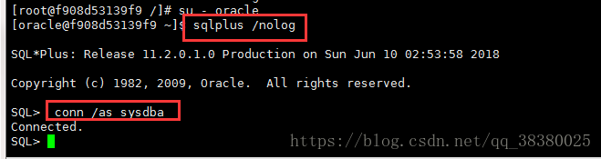

接着执行下面命令

alter user system identified by system;

alter user sys identified by sys;

也可以创建用户

create user test identified by test;

并给用户赋予权限  grant connect,resource,dba to test;